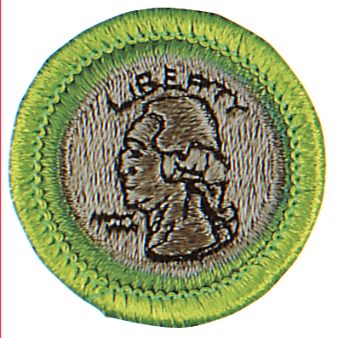
Milwaukee Numismatic Society
2015 – 35th Annual
Coin Collecting Merit Badge Clinic
Saturday, March 21, 2015
7:30 a.m. to 12:30 p.m.
Crowne Plaza Hotel
(6401 S. 13th Street, Milwaukee)
Have your Scouts Find out about this interesting lifetime hobby, earn the Coin Collecting Merit Badge, and receive free numismatic literature!

BEFORE ATTENDING THE CLINIC, YOU MUST:

ONE: Read the Coin Collecting Merit Badge Book (earlier printings are fine for reference purposes, but the requirements we’ll follow are in the 2002 or later editions.) The book can be purchased at the Trading Post and at most stores handling Scouting supplies. They can also be borrowed from libraries affiliated with the Milwaukee County Federated System. Scouts will be reviewed on requirements: 1, 2a-f, 3, 4, 5 a, b, 6, 7, 8, 9d and 10b. You must read the book. Certain required things are covered in the book that are not covered in the on-line worksheet.

TWO: Collect from circulation and bring (requirement 6) five different state quarters and be prepared to describe the 1999-2008 State Quarters program.

THREE: Collect from circulation and bring (requirement 7) a type set of U.S. coin currently in circulation. This type set must include one of each: 1 cent, 5 cent, 10 cent, 25 cent, 50 cent coins and the Native American Dollar. The dates do not have to be the same. Know the location of the mint marks and the designers’ initials. Prepackaged proof and mint sets are not acceptable.

FOUR: Collect and bring (requirement 9d) a date set of a single type from the year of your birth through last year (2014).

FIVE: Registrants will be sent a coin-related article to read. It will not be discussed at the clinic, but you will be reviewed on it (requirement 5b). You may also be sent several pages from reference catalogs (requirement 5a). This will be discussed as the clinic and you will be reviewed.

SIX: Bring only the coins required for the Merit Badge. Leave the rest of your collection at home. Of the coins you bring, at least one collection must be presented in approved storage / display devices (requirement 4). See pages 57 thru 59. At the clinic, the Scout will complete the other requirements and then be reviewed. Adult leaders are welcome to observe, but may not sit with the Scouts..

SEVEN: Check-in begins at 7:30 a.m. The clinic is $6.00 per Scout. Make checks payable to Boy Scouts of America.

Scoutmaster, please have the scouts bring a signed and FILLED IN merit badge (blue) card. Have him bring a notepad and his required coin sets with him to the clinic. Remind Scouts to wear uniforms and provide a copy of this flier to each scout planning to attend so he can study the correct requirements. Please register at the Scout Service Center. Troops and individuals welcome. Any questions contact Leon Saryan (414) 282-1919. Note: This year the clinic is being held in conjunction with the South Shore Coin Club Coin Show. This provides a wonderful opportunity for Scouts to experience firsthand a coin show (requirement 10b) and gives them a chance to expand their collections. Everyone will be able to visit the show after the clinic.

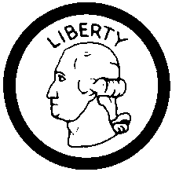

COIN COLLECTING MERIT BADGE CLINIC

REGISTRATION FORM

Troop ______ District _________________________ wishes to register _______ Scouts for the clinic. There will be _________ adults present for the full time. Registration is limited to the first 65 Scouts.

__________# Scouts @ $6.00 - Total Amount Enclosed $____________ Acct # 2015 - D754

Scout Name Rank Address City/Zip Phone
______________________________________________________________________________________________________
______________________________________________________________________________________________________
______________________________________________________________________________________________________
______________________________________________________________________________________________________

Adult Leader_______________________________________________ City/Zip____________________________________
Address __________________________________________________ Phone _____________________________________

Please return to: Three Harbors Council, BSA  330 S. 84 Street  Milwaukee, WI  53214-1468

